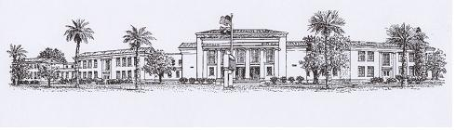

CHANDLER HIGH SCHOOL ORCHESTRA

350 N ARIZONA AVE
CHANDLER, AZ 85225
480-812-7700
Memo for CHS Orchestra Girls’ Uniforms 2016-17

Welcome to the Chandler High School Orchestra. We take great pride in our orchestra and want to present a professional look at our concerts. We have a dress that every girl will have to wear. The dress we use is from Formal Fashions and must be ordered through the internet. All girls will order the Empire dress with the performance knit material and Bell Sleeves. Each girl will choose the neck line and piping for their dress. Below is the link to Formal Fashions and the dress order information. Please order her dress ASAP because the uniforms can take anywhere between 4-6 weeks to receive. Our first concert is scheduled for September 26 2016 and she will need this dress for that performance.

Formal Fashions Inc.
http://www.formalfashionsinc.com

The following procedure will be followed for ordering the uniforms:
- Go to the Home page
- Click on “Dresses”
- Click on “Empire Style Dresses – Interactive Design / Build Your Own”
- Choose a neckline and click on that picture
  - Here are the neck lines to choose from with the Bell Sleeve:
    - 4902AA, 4912AA, 4922AA, 4932AA, 4942AA, 4952AA, 49N52AA, 4962AA, 4972AA, 4982AA, 4992AA

- Choose Color: Black
- Choose Fabric: Performance Knit
- Choose Trim: Your choice
- Watch “How to measure” video or click on the Sizing Chart.
- Order: Size___, Cut: Regular, Fabric: Performance Knit, Quantity: 1

  - Measurements in inches:

    - Bust: ________
    - Waist _________
    - Hips __________
    - Height _________
    - Neck to Floor _____
    - Size ________

‏

